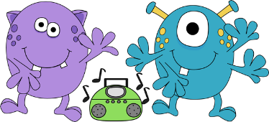 Cool Moves!!

A fun Game to Play at home
Dancing Musical Chairs!!!

Materials Needed: Construction Paper, Music, boom box
This activity is similar to Musical Chairs, but in this version participants are encouraged to move in different ways according to different types of music.
Prepare: A play list featuring different genres of music (jazz, rock, soul, hip hop, cultural music etc) Scatter “islands” (pieces of construction paper) around the activity space – one less than the number of children playing.
Play: Turn on the music and encourage the participants to use their bodies to express how that kind of music makes them feel. When the music stops, participants must find an “island”. Whoever does not make it to an “island” is out and one “island” is removed. Participants who are out should be encouraged to continue dancing on the sidelines.

A Yummy Nutritional treat!
Berry Parfait!!!
Prep Time: 5 minutes Serves: 1
1 cup of sliced strawberries
½ cup of low-fat vanilla yogurt
½ cup square wheat cereal (or granola)

Make one layer of strawberries in a cup
Add a layer of yogurt
Add a layer of cereal or granola
Repeat layers

Ingredients: Instructions:

